Types of Operator

* General Operators
* Arithmetic Operators
* Relational Operators
* Logical Operators

General Operators

Following table shows the general operators supported by Tableau. These operators act on numeric, character and date data types.

|  |  |  |
| --- | --- | --- |
| **Operator** | **Description** | **Example** |
| **+(addition)** | It Adds two numbers. It concatenates two strings. It adds days to dates. | 7 + 3 Profit + Sales 'abc' + 'def' = 'abcdef' #April 15, 2004# + 15 = #April 30, 2004# |
| **–(subtraction)** | I subtracts two numbers. It subtracts days from dates. | -(7+3) = -10 #April 16, 2004# - 15 = #April 1, 2004# |

Arithmetic Operators

Following table shows the arithmetic operators supported by Tableau. These operators act only on numeric data types.

|  |  |  |
| --- | --- | --- |
| **Operator** | **Description** | **Example** |
| **\*(Multiplication)** | Numeric Multiplication | 23*2 = 46 |
| **/(Division)** | Numeric Division | 45/2 = 22.5 |
| **%(modulo)** | Reminder of numeric division | 13 % 2 = 1 |
| **^(power)** | Raised to the power | 2^3 = 8 |

Comparison Operators

Following table shows the comparison operators supported by Tableau. These operators are used in expressions. Each operator compares two numbers, dates, or strings and returns a Boolean (TRUE or FALSE). Booleans themselves, however, cannot be compared using these operators.

|  |  |  |
| --- | --- | --- |
| **Operator** | **Description** | **Example** |
| **= = or = (Equal to)** | Compares two numbers or two strings or two dates to be equal. Returns the Boolean value TRUE if they are else returns false. | ‘Hello’ = ‘Hello’ 5 = 15/ 3 |
| **!= or <> (not equal to)** | Compares two numbers or two strings or two dates to be unequal. Returns the Boolean value TRUE if they are else returns false. | ‘Good’ <> ‘Bad’ 18 != 37 / 2 |
| **> (greater than)** | Compares two numbers or two strings or two dates where the first argument is greater than second. Returns the boolean value TRUE if it is the case else returns false. | [Profit] > 20000 [Category] > ‘Q’ [Ship date] > #April 1, 2004# |
| **< (less than)** | Compares two numbers or two strings or two dates where the first argument is smaller than second. Returns the boolean value TRUE if it is the case else returns false. | [Profit] < 20000 [Category] < ‘Q’ [Ship date] < #April 1, 2004# |
|  |  |  |

Logical Operators

Following table shows the logical operators supported by Tableau. These operators are used in expressions whose result is a Boolean giving the output as TRUE or FALSE.

|  |  |  |
| --- | --- | --- |
| **Operator** | **Description** | **Example** |
| **AND** | If the expressions or Boolean values present in both sides to AND operator is evaluated to be TRUE then the result is TRUE. Else the result is FALSE. | [Ship Date] > #April 1, 2012# AND [Profit] > 10000 |
| **OR** | If any one or both of the expressions or Boolean values present in both sides to AND operator is evaluated to be TRUE then the result is TRUE. Else the result is FALSE. | [Ship Date] > #April 1, 2012# OR [Profit] > 10000 |
| **NOT** | This operator negates the Boolean value of the expression present after it. | NOT [Ship Date] > #April 1, 2012# |

Operator Precedence

The table below describes the order in which operators are evaluated. The top row has the highest precedence. Operators on the same row have the same precedence. If two operators have the same precedence they are evaluated from left to right in the formula. Also parentheses can be used. The inner parentheses are evaluated before the outer parentheses.

|  |  |
| --- | --- |
| **Precedence** | **Operator** |
| **1** | –(negate) |
| **2** | ^(power) |
| **3** | *, /, % |
| **4** | +, – |
| **5** | ==, >, <, >=, <=, != |
| **6** | NOT |
| **7** | AND |
| **8** | OR |

Functions

* Number Functions
* String Functions
* Date Functions
* Logical Functions
* Aggregate Functions

Number Functions

These are the functions used for numeric calculations. They only take numbers as inputs.Below are some examples of important number functions.

|  |  |  |
| --- | --- | --- |
| **Function** | **Description** | **Example** |
| **CEILING(number)** | Rounds a number to the nearest integer of equal or greater value. | CEILING(2.145) = 3 |
| **POWER(number, power)** | Raises the number to the specified power. | POWER(5,3) = 125 |
| **ROUND(number, [decimals])** | Rounds numbers to a specified number of digits. | ROUND(3.14152,2) = 3.14 |

String Functions

String Functions are used for string manipulation. Below are some important string functions with examples.

|  |  |  |
| --- | --- | --- |
| **Function** | **Description** | **Example** |
| **LEN(string)** | Returns the length of the string. | LEN("Tableau") = 7 |
| **LTRIM(string)** | Returns the string with any leading spaces removed. | LTRIM(" Tableau ") = "Tableau" |
| **REPLACE(string, substring, replacement)** | Searches string for substring and replaces it with replacement. If substring is not found, the string is not changed. | REPLACE("GreenBlueGreen", "Blue", "Red") = "GreenRedGreen" |
| **UPPER(string)** | Returns string, with all characters uppercase. | UPPER("Tableau") = "TABLEAU" |

Date Functions

Tableau has a variety of date functions to carry out calculations involving dates. All the date functions use the date_part which is a string indicating the part of the date like - month, day or year. Below are the examples of some of the important date functions.

|  |  |  |
| --- | --- | --- |
| **Function** | **Description** | **Example** |
| **DATEADD(date_part, increment, date)** | Returns an increment added to date. The type of increment is specified in date_part. | DATEADD('month', 3, #2004-04-15#) = 2004-07-15 12:00:00 AM |
| **DATENAME(date_part, date, [start_of_week])** | Returns date_part of date as a string. The start_of_week parameter is optional. | DATENAME('month', #2004-04-15#) = "April" |
| **DAY(date)** | Returns the day of the given date as an integer. | DAY(#2004-04-12#) = 12 |
| **NOW( )** | Returns the current date and time. | NOW( ) = 2004-04-15 1:08:21 PM |

Logical Functions

These functions evaluate some single value or result of an expression and give a boolean output.

|  |  |  |
| --- | --- | --- |
| **Function** | **Description** | **Example** |
| **IFNULL(expression1, expression2)** | The IFNULL function returns the first expression if the result is not null, and returns the second expression if it is null. | IFNULL([Sales], 0) = [Sales] |
| **ISDATE(string)** | The ISDATE function returns TRUE if the string argument can be converted to a date and FALSEif it cannot. | ISDATE("11/05/98") = TRUE ISDATE("14/05/98") = FALSE |
| **MIN(expression)** | The MIN function returns the minimum of an expression across all records or the minimum of two expressions for each record. |  |
|  |  |  |

Aggregate Functions

|  |  |  |
| --- | --- | --- |
| **Function** | **Description** | **Example** |
| **AVG(expression)** | Returns the average of all the values in the expression. AVG can be used with numeric fields only. Null values are ignored. |  |
| **COUNT(expression)** | Returns the number of items in a group. Null values are not counted. |  |
| **MEDIAN(expression)** | Returns the median of an expression across all records. Median can only be used with numeric fields. Null values are ignored. |  |
| **STDEV(expression)** | Returns the statistical standard deviation of all values in the given expression based on a sample of the population. |  |

Numeric Calculations

Numeric calculations in Tableau are done using a wide range of inbuilt functions available in the formula editor.

In this chapter we will see how to apply calculations to the fields. The calculations can be as simple as subtracting the values of two fields or applying a aggregate function to a single field.

Below are the steps to create a calculation field and use numeric functions in it.

Create Calculated Field

While connected to Sample-superstore, go to the Analysis menu and click on Create a Calculated field, as shown in the below diagram.

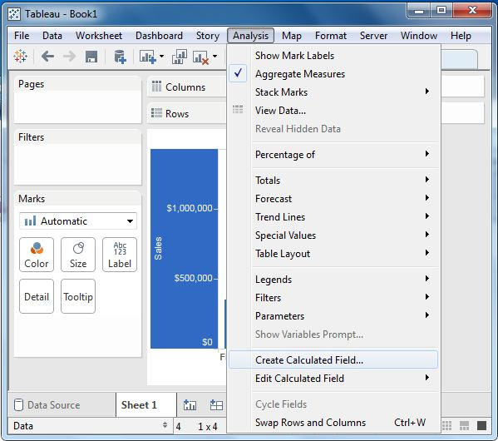

Calculation Editor

The above step opens a calculation editor which lists all the functions that is available in Tableau. You can change the dropdown value and see only the functions related to numbers.

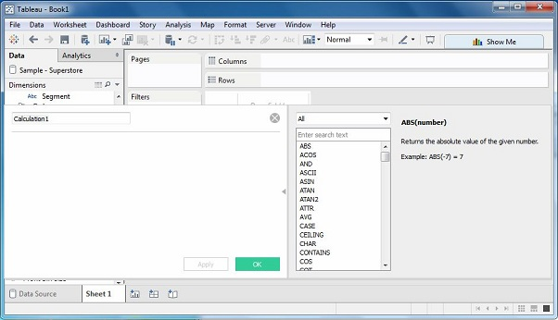

Create a Formula

We aim to study the difference between profit and discount for different shipping mode of the products. So we create a formula subtracting discount from profit as shown below. Also we name this field as profit_n_discount.

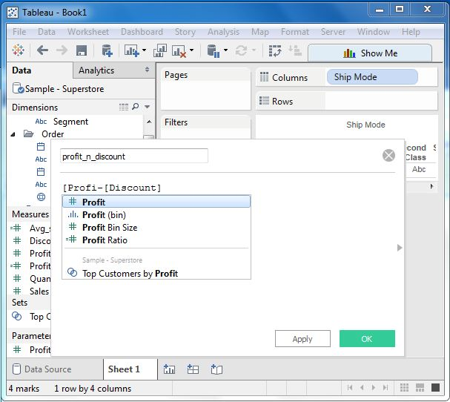

Using the Calculated Field

The above calculated field can be used in the view by dragging it to the Rows shelf as shown below. It produces a bar chart showing the difference between profit and discount for different shipping modes.

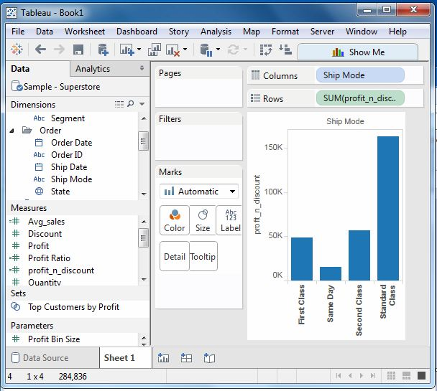

Applying Aggregate Calculations

In a similar manner as above we can create a calculated field using aggregate function. Here we create AVG(sales) values for different ship mode. We write the below formula in the calculation editor.

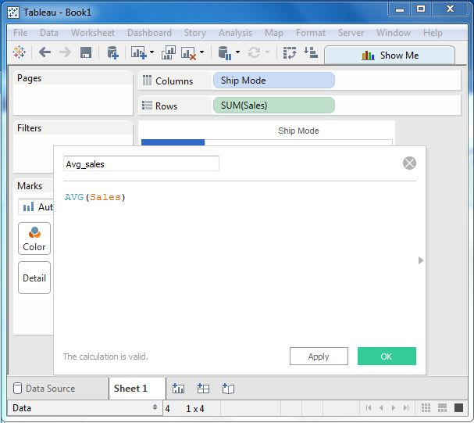

On clicking OK and dragging the Avg_Sales field to the Rows shelf we get the below view.

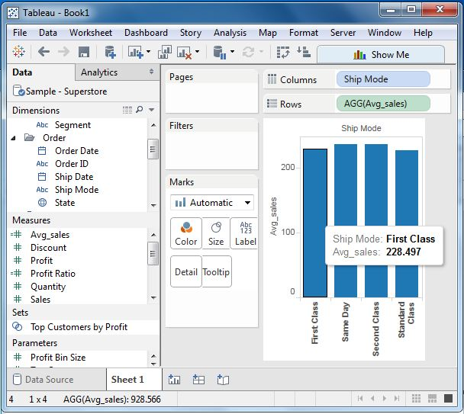

String Calculations

Create Calculated Field

While connected to Sample superstore, go to the Analysis menu and click on Create a Calculated field, as shown in the below diagram.



Calculation Editor

The above step opens a calculation editor which lists all the functions that is available in Tableau. You can change the dropdown value and see only the functions related to strings.

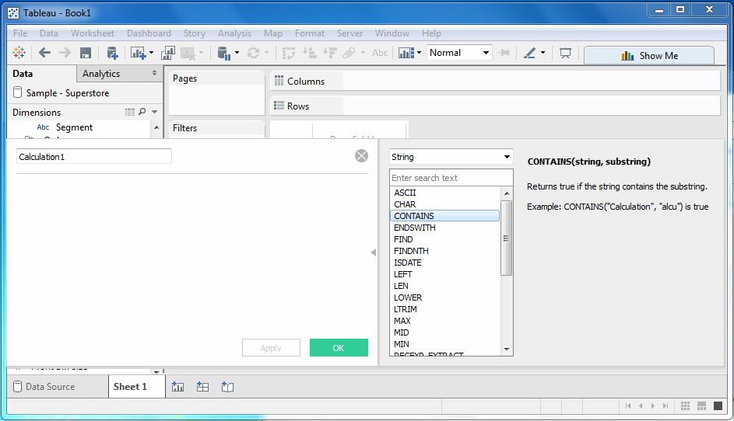

Create a Formula

Let's find out the sales in the cities which contain the letter “o”. For this we create the formula as shown below.

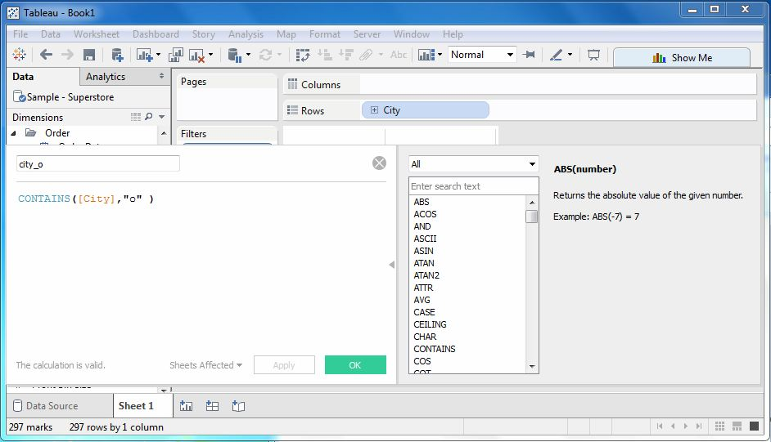

Using the Calculated Field

Now to see the created field in action we can drag it to the Rows shelf and drag the Sales field to the Columns shelf. The below diagram shows the Sales values.

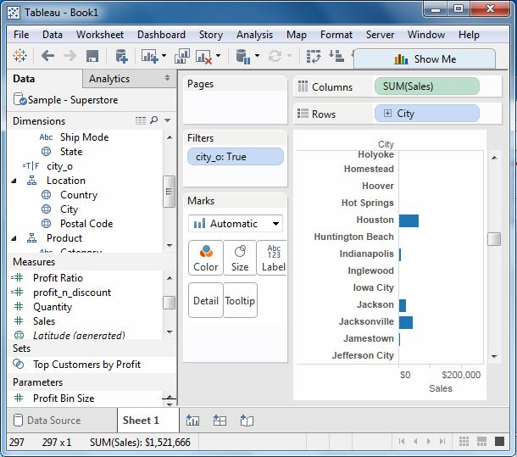

Date Calculations

Create Calculated Field

While connected to Sample superstore, go to the Analysis menu and click on Create a Calculated field, as shown in the below diagram.



Calculation Editor

The above step opens a calculation editor which lists all the functions that is available in Tableau. You can change the dropdown value and see only the functions related to Date.

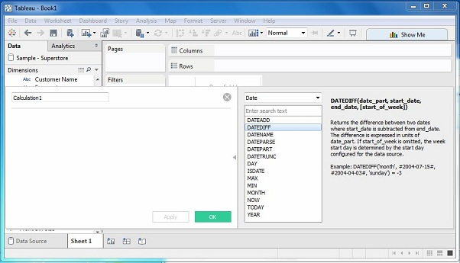

Create a Formula

Let's find out the sales volume along with the difference in date of sales in months from 21st March 2009. For this we create the formula as shown below.

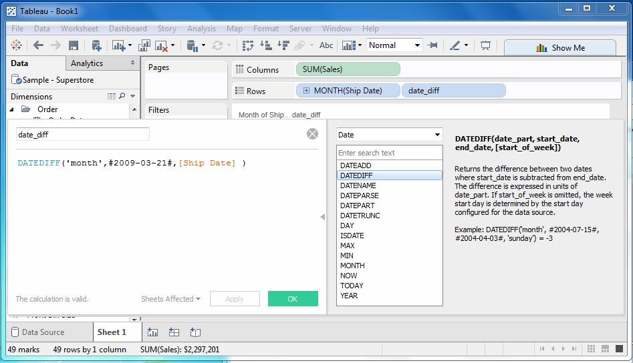

Using the Calculated Field

Now to see the created field in action we can drag it to the Rows shelf and drag the Sales field to the Columns shelf. Also drag the ship Date with months. The below diagram shows the Sales values.

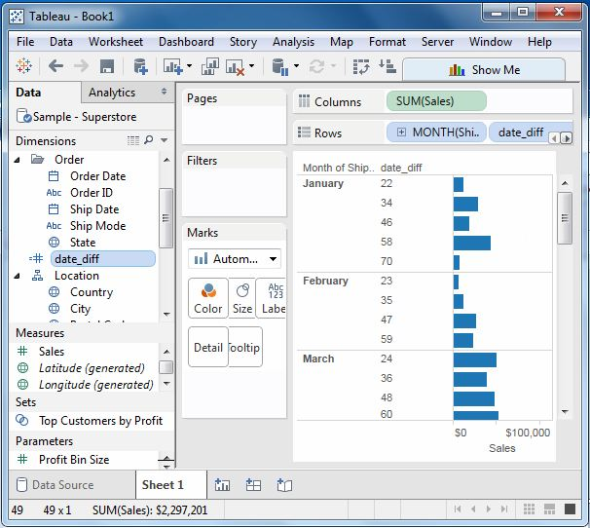

Table Calculations

These are the calculations which are applied to the values in the entire table. For example, for calculating a running total or running average we need to apply a single method of calculation to an entire column. Such calculations cannot be performed on some selected rows.

Table has a feature called **Quick Table Calculation** which is used to create such calculations. The steps to be applied in Quick Table calculation are as follows:

STEP-1

Select the measure on which the table calculation has to be applied and drag it to column shelf.

STEP-2

Right click on the measure and choose the option **Quick Table Calculation**.

STEP-3

Choose one of the below options to be applied on the measure.

* **Running Total**
* **Difference**
* **Percent Difference**
* **Percent of Total**
* **Rank**
* **Percentile**
* **Moving Average**
* **Year to Date (YTD) Total**
* **Compound Growth Rate**
* **Year over Year Growth**
* **Year to Date (YTD) Growth**

LOD Expressions

Types of LOD

There are three main types of LOD expressions.

* **FIXED LOD** This expressions compute values using the specified dimensions without reference to any other dimensions in the view.
* **INCLUDE LOD** This level of detail expressions compute values using the specified dimensions in addition to whatever dimensions are in the view.
* **EXCLUDE LOD** These levels of detail expressions subtract dimensions from the view level of detail.

FIXED Level of Detail Expressions

Let's find the amount of Sales for each state in each region. Here we first create the formula field named Regional Sales using the formula below.

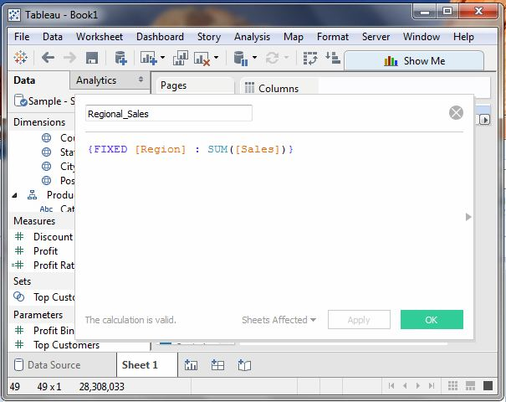

Next we drag the Region and State filed to the Rows shelf and the calculated field to the Text shelf under the Marks card. We also drag the Region field to the Color shelf. This produces the below view which shows a fixed value for different states. That is because we have fixed the dimension as region for the calculation of Sales value.

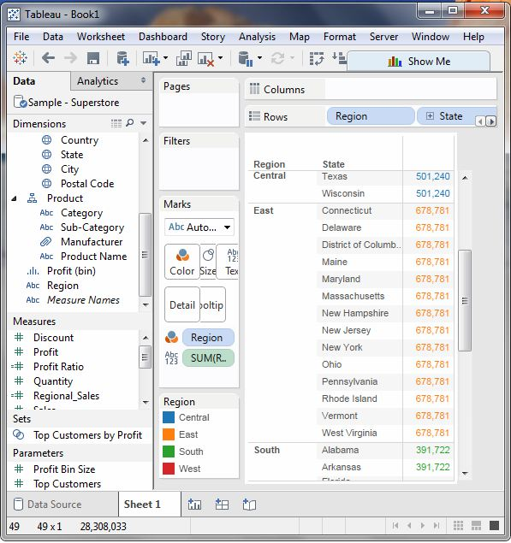

INCLUDE Level of Detail Expressions

INCLUDE level of detail expressions compute values using the specified dimensions in addition to whatever dimensions are in the view. Let's calculate the sum of sales per state for each sub-category of products.

For this we drag the Sub-Category field to the Rows shelf. The we write the expression as shown below in the Columns shelf. It produces the below view which includes both the dimensions in the calculations.

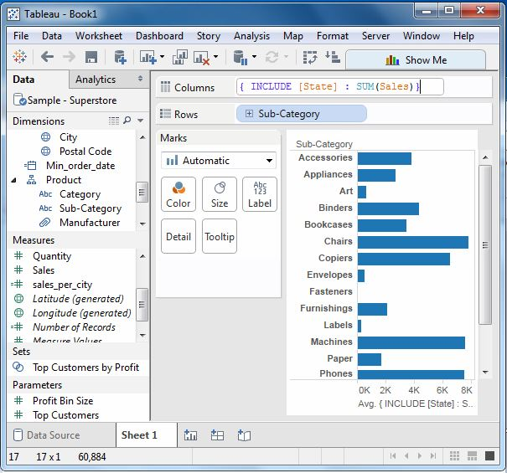

EXCLUDE Level of Detail Expressions

EXCLUDE level of detail expressions specify dimensions to exclude from the view level of detail. Let's exclude Region from Sales figure calculated for every month. We create the formula as shown below.

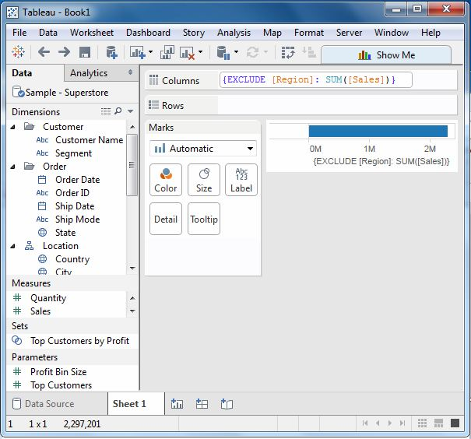

On dragging the relevant fields to the respective shelves we get the final view for the EXCLUDE LOD.

